Thieves Guild:

Leader Cards:

1) Jarl Maven Black Brair

i) Summon a random Imperial Soldier, Summon 2 if fighting the Rebels

ii) Summon Two random Thieves

2) Guild Master Mercer (Cannot use Mercer Unit card if he is chosen as the leader.)

i) Steal an unused card from opponents deck to use it for yourself.

ii) Reveal 3 Of opponent's cards

3) Brynjolf

Unit Cards: 24 (Class, Strength, Level, Ability (if any))

Melee:

1) Bribed Riften Guard (Melee, 1, Novice)

2) Bribed Riften Veteran Guard (Melee, 3, Apprentice)

3) Maul (Melee, 4, Adept) Reveal opponent's 1 random card. (When placed)

4) Mjoll The Lioness (Melee, 7, Expert)

Grimsever : Eliminate a single opponent's Melee unit up to level 7

5) Mercer Frey (Melee, 8, Master)

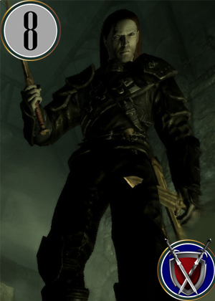

Betray For Benefit: Betray and kill a friendly unit in Frontlines Zones to add the victims strength to Mercer's total. Cannot exceed 14. After this, Mercer becomes Hero Card only if total strength achieved is atleast 10. Cannot Betray cards with Strength above 6. Victim is added to opponent's Discard pile and can be reused with a medic card. If done so, the revived victim will gain double Strength.

6) Dirge (Melee, 3, Adept)

5) Delvin Mallory (Melee, 7, Expert)

Bribe any unit on the opponent's side to change side upto Level 7.

6) Cynric Endell (Melee, 2, Novice)

7) Thrynn (Melee, 2, Novice)

8) Thief (Melee, 1, Novice) Adds +1 Strength to all cards in the row

9) Vipir The Fleet (Melee, 3, Apprentice)

10) Etienne Rarnis (Melee, 4, Adept)

11) Grelka (Melee, 2, Apprentice)

12) Gallus Nightingale (Melee, 6, Expert)

Mage:

1) Maramal (Healer [Medic] Mage, 4, Adept)

Pick a card from your discard pile and play it instantly.

2) Marcurio (Hireling Mage[Misc], 5, Adept)

3) Dinya Balu (Mage, 3, Adept)

4) Wylandriah (Mage, 6, Expert)

Shadow:

1) Thief Karliah (Thief Shadow, 8, Master)



2) Nightingale Karliah [HERO] (Archer Shadow, 12, Master)

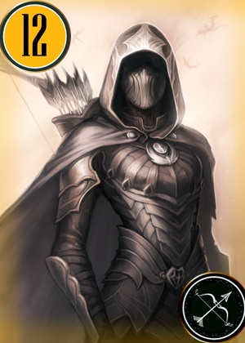

Can only have 1 type of Karliah in the deck

3) Vex (, Spy Shadow, 8, Master)

Place on opposing side, re-draw two cards

4) Sibbi Black Brair (Spy Shadow, 5, Adept)

Place on opposing side, re-draw two cards

5) Tonilla (Fence [Medic], 6, Expert)

Pick a card from your discard pile and play it instantly.

6) Gulum-Ei (Fence[Medic], 2, Apprentice)

Pick a card from your discard pile and play it instantly.

7 ) Niriun (Archer Shadow, 7, Expert)

8) Sapphire (Thief Shadow, 3, Apprentice)

9) Rune (Thief Shadow, 2, Apprentice)

10) Thief (Thief Shadow, 1, Novice) +1 Strength to all cards in the row

Special Cards:

1) Balimund's Fire forge: Double strength of all cards in a zone

2) Anuriel's Corruption: Have a random card on your side defect and join the opponents. Cards with higher strength are more like to defect, Draw a card of your choice from your deck.

3) Elgrim's Potion: Remove debuff's off a single card only.

4) Love of Mara: Choose two humanoid cards of the opposite genders. Increase the strength of the lower unit equivalent to the unit with higher strength. Cannot pair Hero Cards. Incase any one of the unit in the pair is eliminated, the other's strength will be doubled.